1 | b
2 | c
3 | d
4 | b
5 | d
6 | a
7 | b
8 | c
9 | c
10 | a
11 | b
12 | d
13 | b
14 | c
15 | d
16 | Free
17 | b
18 | a
19 | c
20 | c
21 | a
22 | c
23 | d
24 | d
25 | a
26 | c
27 | c
28 | a
29 | b
30 | c

31.

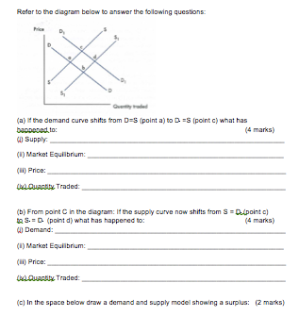
32.

33.

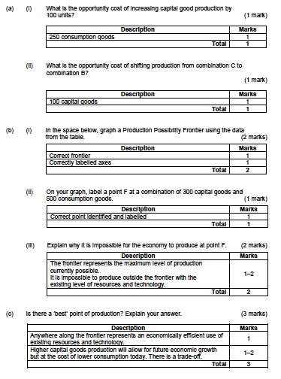

34.

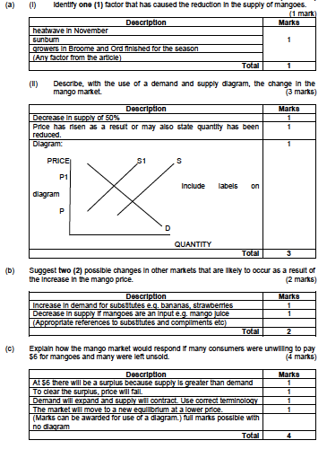

35.

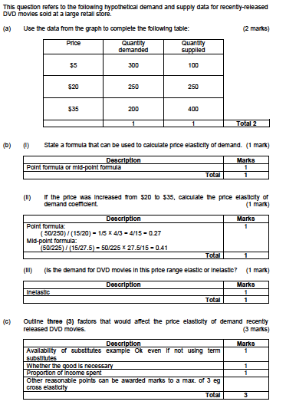

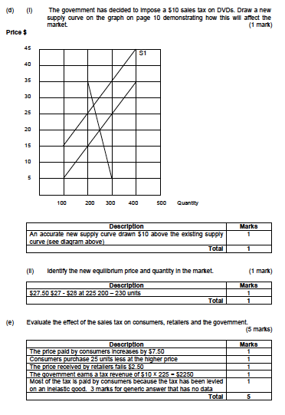

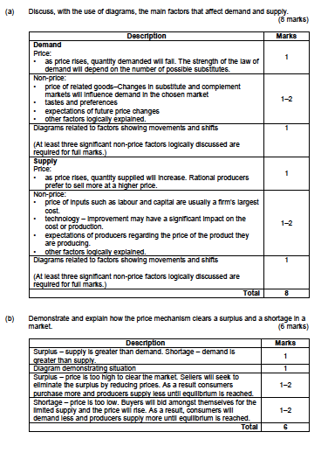
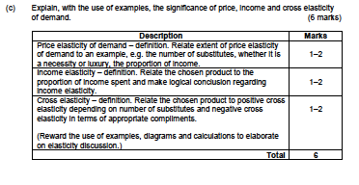
35.

36.

a.) Describe the meaning of price elasticity of supply.
(3 marks)
Description | Mark
Definition of Elasticity | 1
Definition of Supply | 1
Use of either graph or formula in explanation | 1

b.) Using examples distinguish between a good that is supply elastic and one that is supply inelastic.
Description | Mark
Correct example of a Supply Elastic good | 1-2
Correct example of a Supply Elastic good | 1-2

c.) Give an example of a good that is perfectly supply inelastic.

Description | Mark
Correct example | 1
Use of graph, coefficient or formula | 1

d.) explain three (3) factors that determine price elasticity of supply.

Description | Mark
Factors:  Time  Expectations  Resources  Stocks/Inventories | 1 mark for each factor  1 mark for correct explanation & example

(6 marks)

